
Mathematics Specialist
Test 2 2016

Functions

NAME: _______________________________________________ TEACHER: MLA

50 marks 50 minutes

SCSA formulae sheets, ClassPads and a double-sided A4 sheet of notes may be used
Question 1 [2 marks]
Use an algebraic method to solve$\left|2x-4\right|=10.$

Question 2 [4 & 1 = 5 marks]
(a) $If f\left(x\right)=-\left(x^{2}+3x-10\right) , express \left|f\left(x\right)\right| and f\left(\left|x\right|\right) as piecewise functions.$

(b) Using your ClassPad, or otherwise, solve $\left|f\left(x\right)\right|=f\left(\left|x\right|\right).$

Question 3 [3 & 3 = 6 marks]
On the axes provided, sketch the following functions:
(a) $y=f^{-1}(x)$
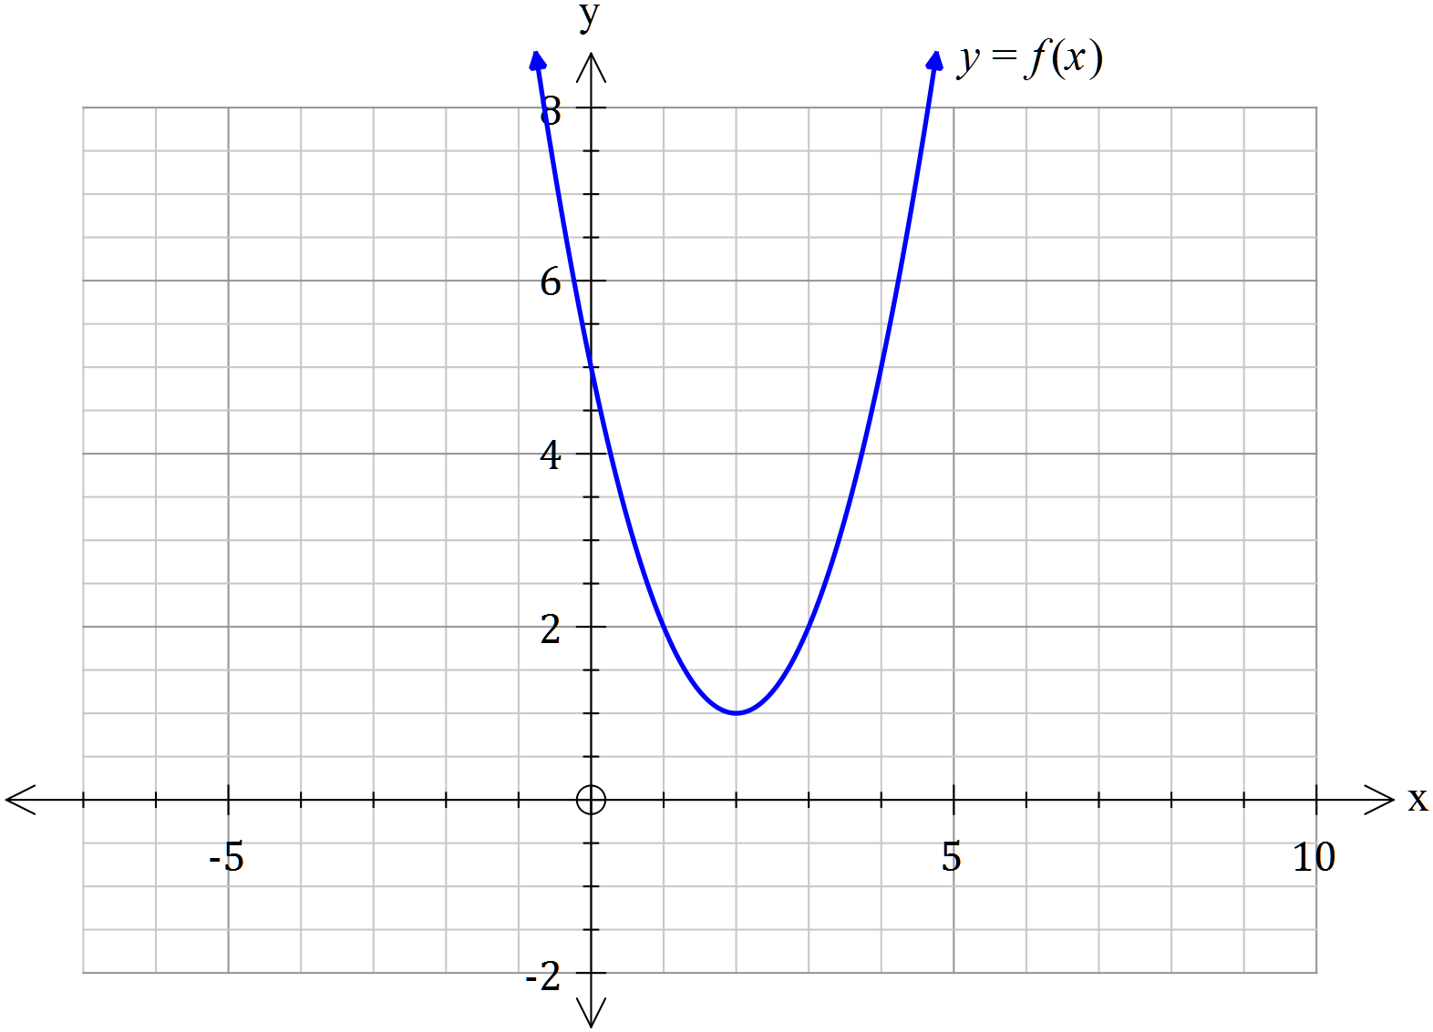

(b) $y=\frac{1}{f(x)}$


Question 4 [3 marks]
If $f\left(x\right)=2x^{2} and g\left(x\right)=\sqrt{2-x} , state the rule for fog\left(x\right)$ and find its domain and range.

Question 5 [3 marks]
With reference to the number line drawn below, determine the appropriate inequality symbol for $∎ , and find the values of p and k if \left|2x-4\right| ∎ k.$

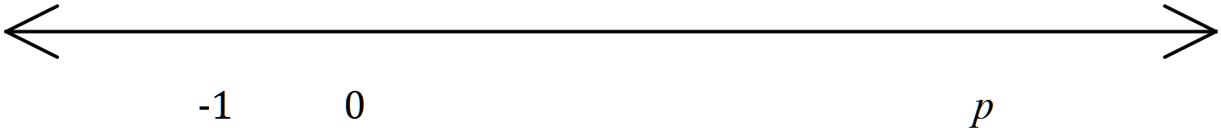

Question 6 [3 & 3 = 6 marks]
(a) Sketch the graphs of $f\left(x\right)=\left|x+k\right| , k>0 and h\left(x\right)=\left|2x-k\right| , k>0$
Be sure to label each graph and to identify all intercepts

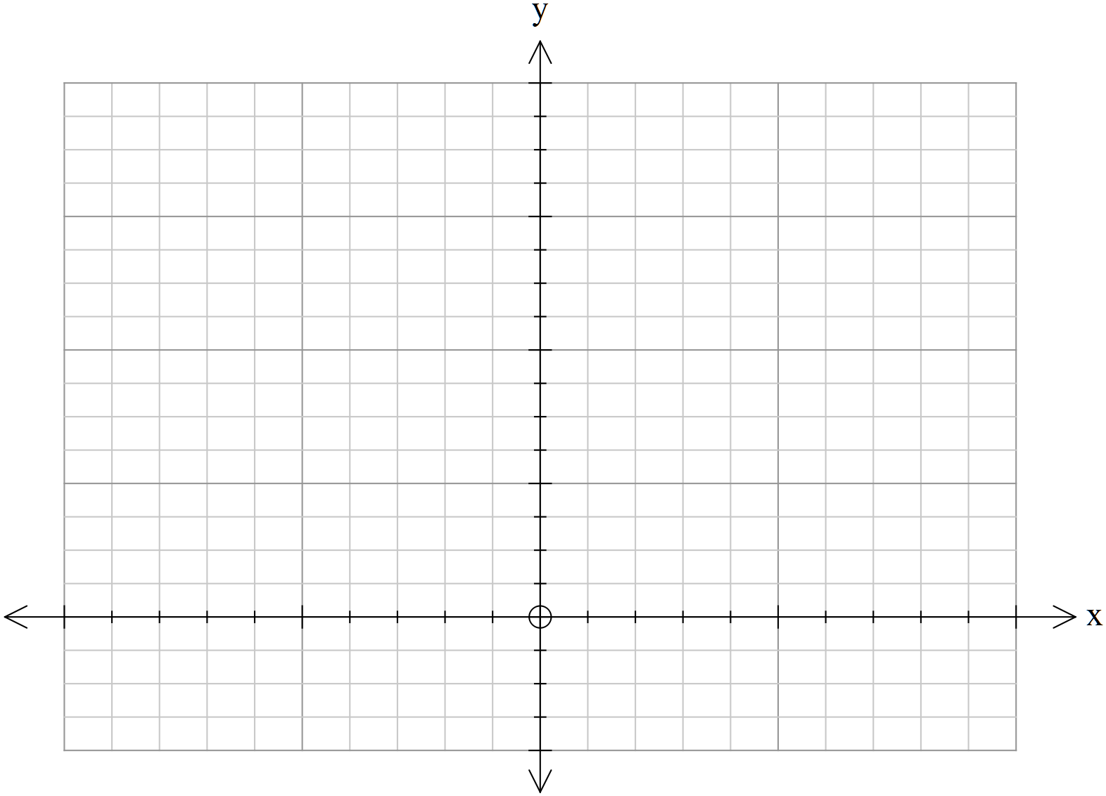

(b) Hence, determine the value(s) of x for which $f(x)≤h(x)$

Question 7 [3 marks]
Consider$f\left(x\right)=\frac{cx+d}{x+e} , where c, d and e are integers$
$f\left(x\right) has the following characteristics$:
- $vertical asymptote with equation x=-4$
- root (zero) at$x=4$
- intercept at$(0, 2)$
Find the values of$c, d and e$.

Question 8 [3 & 5 = 8 marks]
(a) Express $f\left(x\right)=x^{2}+2\left|x-1\right|$ in piecewise form.

(b) (i) Express $f\left(x\right)=\left|x-8\right|+\left|2-x\right|$as a piecewise function.

(ii) $\left|x-8\right|+\left|2-x\right|=4x+4 when x=1$
State the equation used to obtain this solution.

Question 9 [1, 2, 1, 1, 1 & 1 = 7 marks]
Consider$f\left(x\right)=2+{(x-1)}^{2}$ , where $x∈R$
(a) Find $f\left(0\right) and f\left(2\right)$

(b) Use your answers in (a) to show that $f\left(x\right)$ does not have an inverse function

(c) Determine the largest possible domain for$f\left(x\right)$, consisting only of positive numbers, so that $f\left(x\right)$has an inverse function

(d) State the range for $f\left(x\right)$ that corresponds with your domain in (c)

(e) Using your ClassPad, or otherwise, determine the rule for the inverse of $f\left(x\right)$that corresponds with your domain in (c)

(f) State the domain and range for $f^{-1}\left(x\right)$

Question 10 [5, 2 = 7 marks]

Consider $f\left(x\right)=\frac{x^{2}+2x+1}{x-2}$

(a) Using your ClassPad, or otherwise, determine the following:
(i) Stationary points

(ii) Intercept(s)

(iii) Asymptotes

(b) Investigate the behaviour of $f\left(x\right)$ as $x→± ∞$

End of Test 2

